Labelling

Example from History: A Medieval Castle
( ) moat
( ) belfry
( ) battlements
( ) drawbridge
( ) arrow loops
( ) courtyard
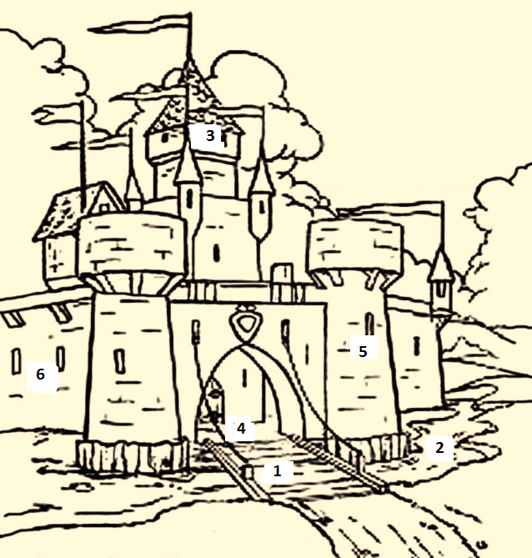

Source: https://www.bing.com/images/

