Macromolecules
Proteins-Enzymes
For Upper Secondary Education, 16+

Background ….
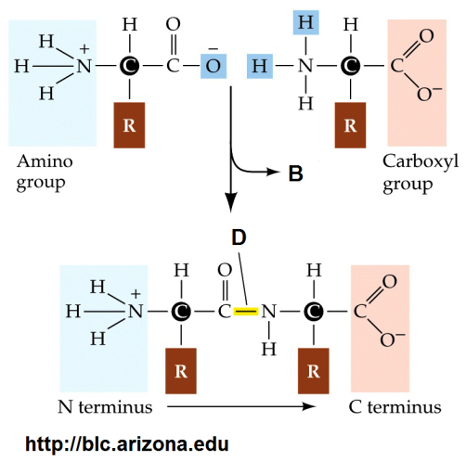Remember the structure of an aminoacid and the reaction joining two such molecules.
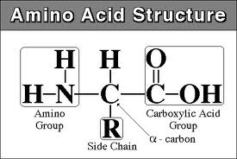

http://legacy.owensboro.kctcs.edu/gcaplan/anat/notes/amino_acid_structure_2.jpg

- Above, the reaction joining two amino acids is shown. What kind of reaction is it? Underline accordingly. Hydrolysis Condensation

- Name the bond indicated with the letter D. …………………………
- Name the molecule indicated with the letter Β. …………………………
- Name the molecule formed in this reaction. …………………………
- If many amino acids join together then the reaction is known as a ……………………………… reaction.
- Name the four levels of protein structure.
  - ………………………
  - ………………………
  - ………………………
  - ………………………
- i. Explain the term denaturation of a protein.
…………………………………………………………………………………………………………………………………………………………………………………………………………………………
ii. Certain agents/conditions might lead to protein denaturation. Name three.
- …………………………………………………
- …………………………………………………
- …………………………………………………

“Building” proteins!!
The multi-coloured beads you have will be your amino acids and the much smaller single-coloured beads will be the bond joining the amino acids. You also have strings of different strength to use for different models. Among your materials you will find additional model making materials and tools such as cutting pliers.
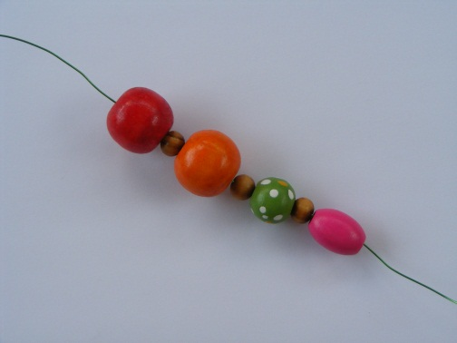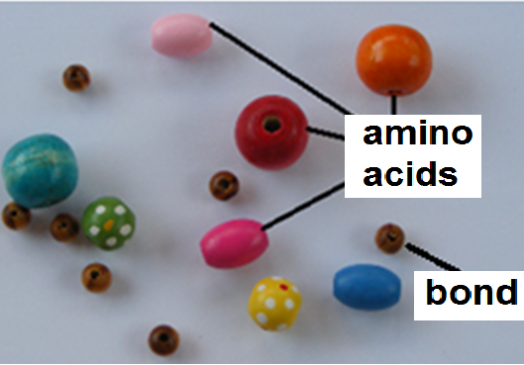

- Your task is to build models which will show the following.
  - A polypeptide chain (primary structure)
  - Secondary structure of a protein – a-helix
  - Tertiary structure of a protein (with an area in secondary structure)
  - A globular protein
  - A fibrous protein with three subunits

- Enzymes
  - Build an enzyme
  - show its active centre
  - build another molecule that would act as the enzyme’s substrate

- Denaturation
Using your models, try to devise a way to show protein denaturation.

Note: The teacher puts the students into groups and makes sure that between the groups all the models are made.
Also, visit these sites!!
- http://cnx.org/content/m11614/latest/
- http://schoolworkhelper.net/protein-structures-primary-secondary-tertiary-quaternary/
- https://www.chem.wisc.edu/deptfiles/genchem/netorial/modules/biomolecules/modules/enzymes/enzyme3.htm
- http://www.worldofteaching.com/enzymespowerpoints.html
- http://www.moleculesinmotion.com/

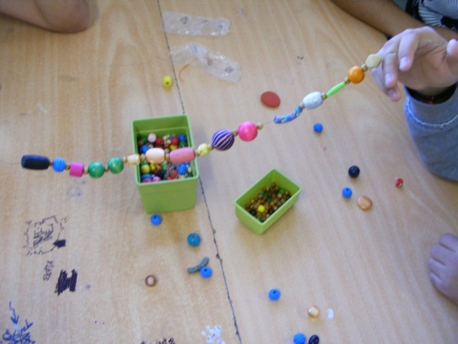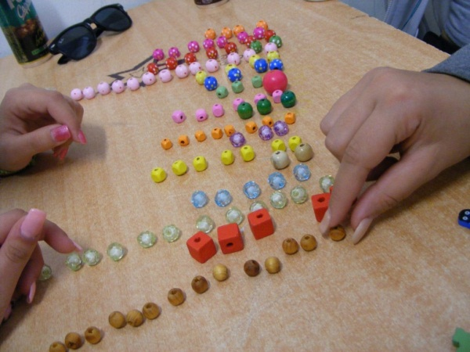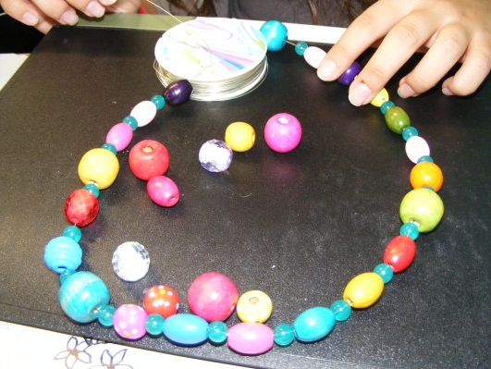Samples
