Macromolecules
Carbohydrates
For Upper Secondary Education, 16+

Background ….
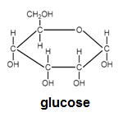Remember the structure of glucose and the reaction joining two such molecules.
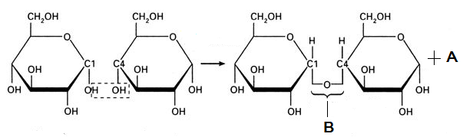

- Shown above is the reaction joining two glucose molecules. Name the reaction by underlining accordingly. Hydrolysis Condensation
- Name the bond indicated with the letter B. …………………………
- Name the molecule indicated with the letter A. …………………………
- Name the molecule formed in this reaction. …………………………
- If many glucose molecules join together, then the reaction is known as a ……………………………… reaction.
- The table below shows three glucose polymers. Fill in the information that is missing.

Polymer | In plants / In Animals | Main biological role
Starch
Glycogen
Cellulose

The polysaccharides mentioned above are made of glucose molecules joined in a specific way which is characteristic in each case. Drawings of their structure is shown below.
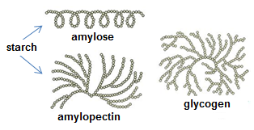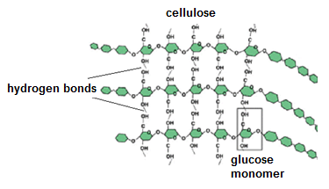
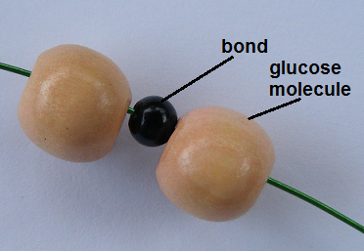“Building” carbohydrates!!
The larger beads will be your glucose molecules and the much smaller beads will be the bond joining the molecules. You also have strings of different strength to use for your models, as well as tools like cutting pliers.
Your task is to build models which will show the following.
  - Maltose
  - Starch (amylose)
  - Glycogen
  - Cellulose

Samples
