Macromolecules
Lipids
For Upper Secondary Education, 16+
Aim
You will be given simple materials with which you will create your own models of lipids.
Additional aim
To make a model of the fluid mosaic model of the biological membrane.
Background….
Name the three general lipid categories you have studied.
…………………………………, ………………………………. and ……………………………… .
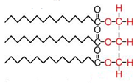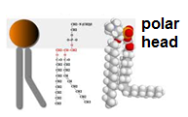

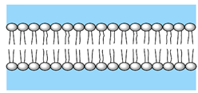Biological membranes are made mainly out of phospholipids which form bilayers as shown on the drawing.
- Explain why phospholipids form bilayers.

- Use the materials given to make:
  - A triglyceride molecule
  - A phospholipid molecule
  - A model of the phospholipid bilayer.

- Now try to add the other components of the biological membrane to your previous model (simple phospholipid bilayer) in order to make a model of the biological membrane!!

Also, visit these sites!!
- http://www.johnkyrk.com/cellmembrane.html
- http://www.susanahalpine.com/anim/Life/memb.htm

Samples
